Setting up the Java Development Kit (JRE);

For running Tomcat server , we need Java installed in machine.
For most all IBM machine it is pre-insatlled

You can check folder C:\Program Files\Java\jre6 exists in your machine

If it is not avilable you need to download Jre. and install it.

http://w3-01.ibm.com/download/standardsoftware/win/jre16022en/jre16022en.html

After installtion you need to set up class path. Follow below steps.

Select Start->Settings->Control Panel->System. Click the Advanced tab at the top.

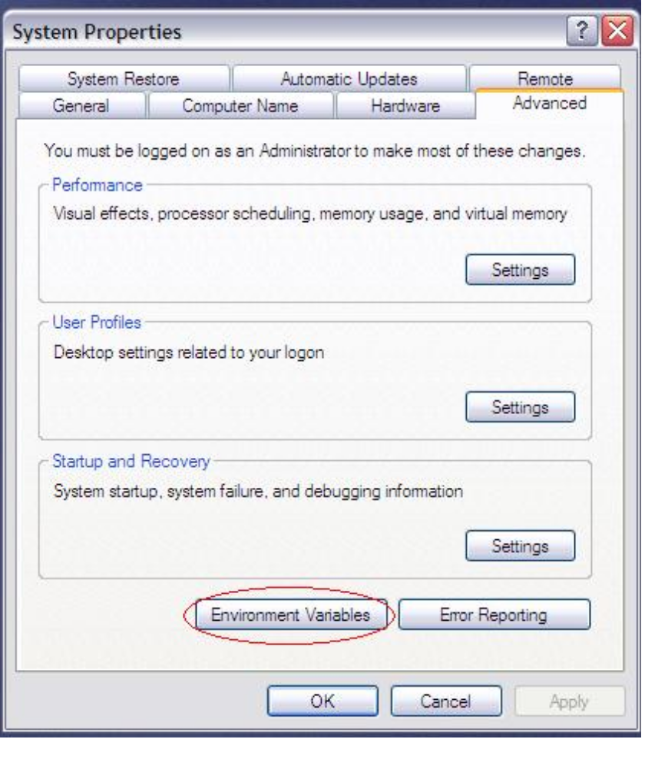

Click on Environment Variables
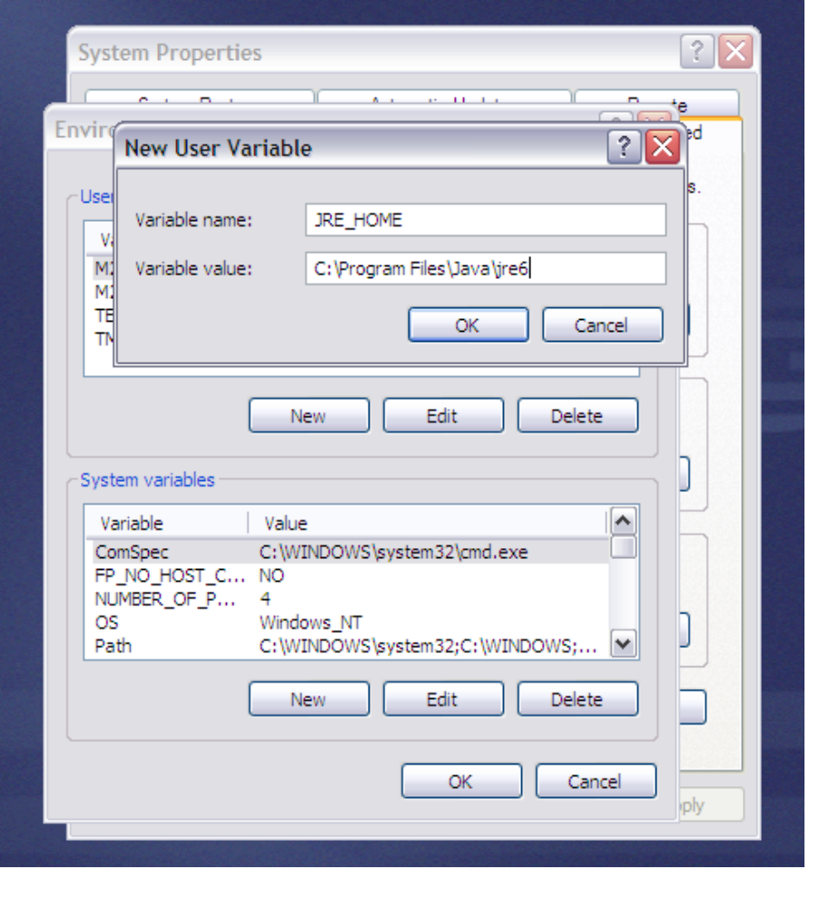
Click on 'New' button under 'User variables for Administrator'
Type Variable Name JRE_HOME
Variable value : path to jre folder (C:\Program Files\Java\jre6 - If you installed in this folder)

Click on “OK” in pop up window and next two window also.

Running Application

Make sure ABCBank-V.1.2.zip unzip in your desktop. Keep same folder name

Open the folder ABCBank-V.1.2

Click on 'start server' icon
Click on 'ABC Bank' icon
For existing user log-ins

User #1
username : rahul
pswd : Rah#238

User #2
username: adarsh
paswd : Ada@872

You can create you own log in by clicking on 'Register' link

